# SOLUTION OF GEEKSOFGEEK and LEETCODE DSA

1. Basic Math Logic Building

Count Digits

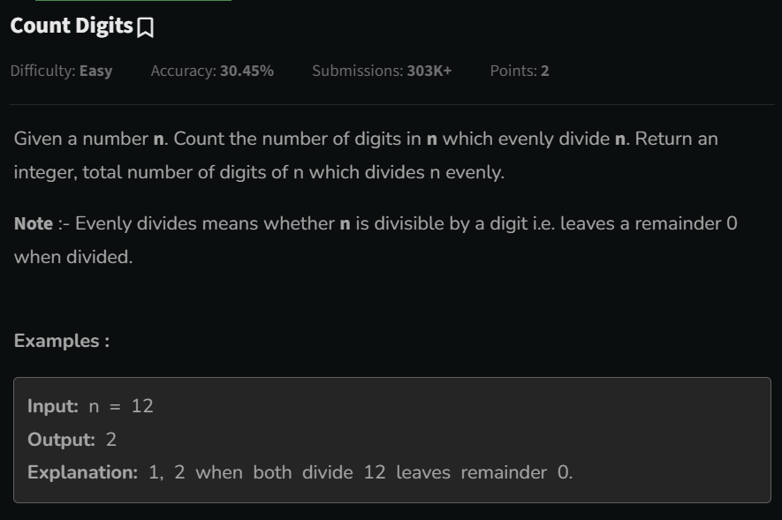

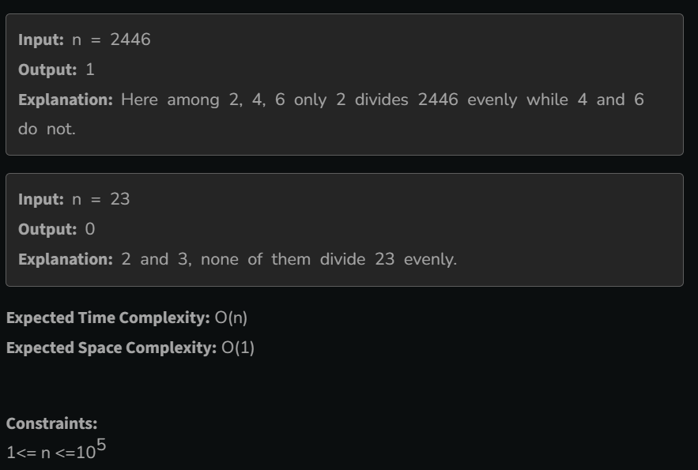

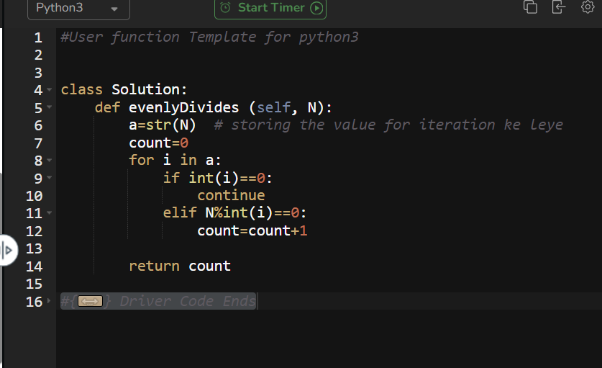

2 .